**Learning Management Platform**

**UCS503 Software Engineering Project Report Mid-Semester Evaluation**

**Submitted by: (102103490) Aayushi Bansal**

**(102103592) Vanshikaa**

**(102103644) Ishika Garg**

**BE Second Year, COE Group No: 1**

**Submitted to:**

**Dr. Nitin Shukla**

**Assistant Professor**



**Computer Science and Engineering Department TIET, Patiala**

**September 2023**

**TABLE OF CONTENTS**

|  |  |  |
| --- | --- | --- |
| **S.No.** | **Assignment** | **Page No.** |
| **1.** | **Project Selection Phase** |  |
| 1.1 | i. Software Bid | 3 |
| **2.** | **Planning Phase** |  |
| 2.1 | i. Project Write Up | 4 |
| 2.2 | ii. Feasibility Report | 5,6 |
| 2.3 | iii. Gantt Chart | 7 |
| **3.** | **Analysis Phase** |  |
| 3.1 | i. Use-Case diagram | 8 |
| 3.2 | ii. Use Case Scenario | 8 |
| 3.3 | iii. Swimlane diagrams | 9 |
| 3.4 | iv. Data Flow Diagrams –Level 0, Level 1 , Level 2 | 10,11 |
| 3.5 | v. Software Requirement Specification (SRS) | 12-20 |
| **4.** | **Design Phase** |  |
| 4.1 | i. Class Diagram | 21 |
| 4.2 | ii. Database Design – ER Diagram | 21 |
| 4.3 | iii. Sequence Diagram | 22 |
| 4.4 | iv. Collaboration Diagram | 22 |
| 4.5 | v. State Chart Diagram | 23 |
| **5.** | **Implementation** |  |
| 5.1 | i. Component Diagram | 23 |
| 5.2 | ii. Deployment Diagram | 24 |
| 5.3 | iii. Screenshots | 25,26 |
| **6.** | **Testing** |  |
| 6.1 | i. Test Case | 27,28 |

# Project Write Up

The document's goal is to compile and evaluate all of the various suggestions that have been made for defining the system and its consumer-related requirements. In order to better understand the project, we will also outline concepts that may be developed later and record ideas that are being considered but may be left as the product develops. Additionally, we will predict and organise how we hope this product will be used.

This document's main goal is to give readers a thorough overview of our software product, including all of its features and objectives. This document outlines the project's user interface, hardware, and software requirements as well as its intended audience. It explains how our customer, our team, and the target market view the product and its capabilities.

This project serves as the Student Attendance Record Manager's prototype. This is meant to be read by university faculty members as well as students to make it easier for them to understand this software.

The main objective is to make a software capable of marking and recording attendance and other features to enrich the user experience of the students. It will be based on using Django and many other technologies to make it robust and this will function by using the camera of the device while incorporating AI to recognize the face of the user to mark the attendance and also using the location to confirm the location. Since this will be a Web based application so there is no need to download any software and it will be fast due to that reason.

# Functional Requirements

The system has different functionalities for an admin and teachers. Admin has higher privileges than teachers. Their functionalities are described below.

Admin Module

Admin has the highest privileges among all as admin is responsible to design the system. Admin register teacher and provide unique id to the teacher. They are responsible to take images of the students and add them to the database. Admin can view and update the details of both students and teachers. They can also view the attendance report. Figure 1 shows the use case for admin,

Teacher Module

Teachers can log in to the system. They can open the application and the images of the students for attendance. They can also view the attendance report. Figure 2 shows the use case for the teacher.

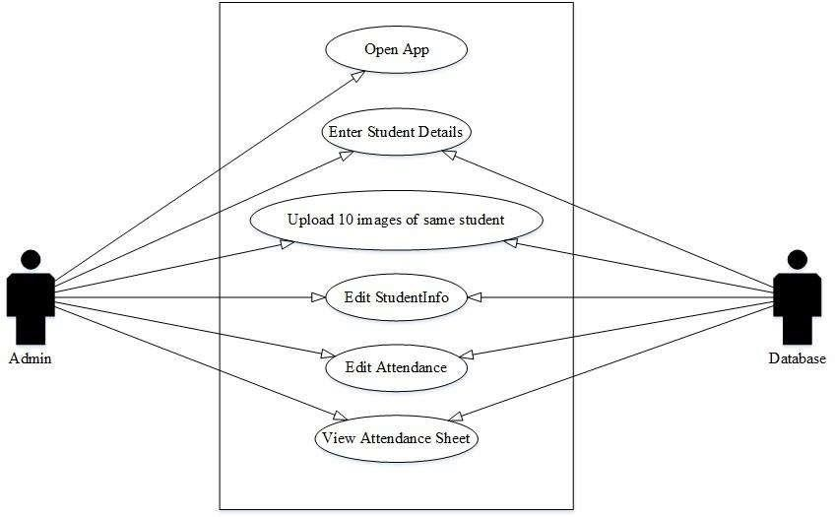

Figure 1 Use Case Admin Module

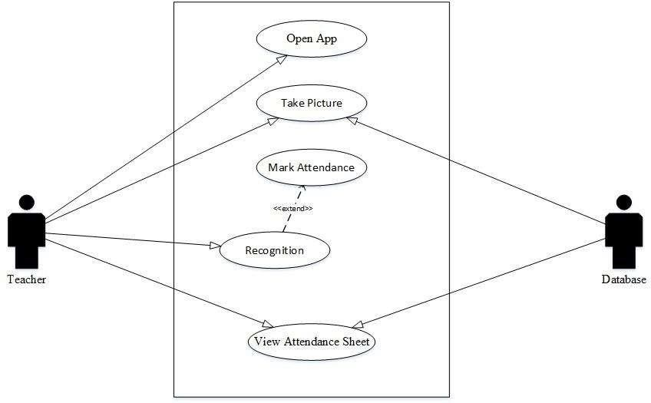

Figure 2 Use Case Teacher Module

**Non-Functional Requirements**

Non-Functional Requirements are the characteristics or attributes of the system that are necessary for the smooth operation of the system. Those requirements are listed below.

* ● The system should perform the process accurately and precisely to avoid problems.
* ● The system should be easy to modify for any updates. Any errors or bugs that are identified should be easy to mend.
* ● The system should be secure and maintain the privacy of the students.
* ● The system should be easy to understand and use.
* ● Execution of the operation should be fast.

## Gantt Chart

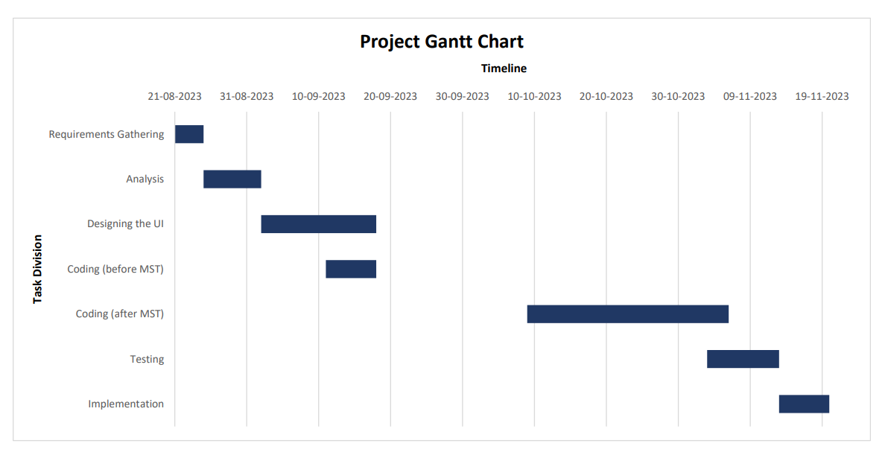

User Case Scenario and Diagram

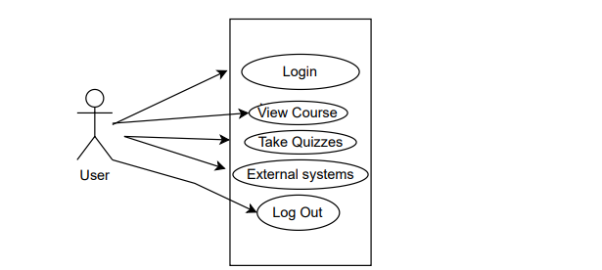

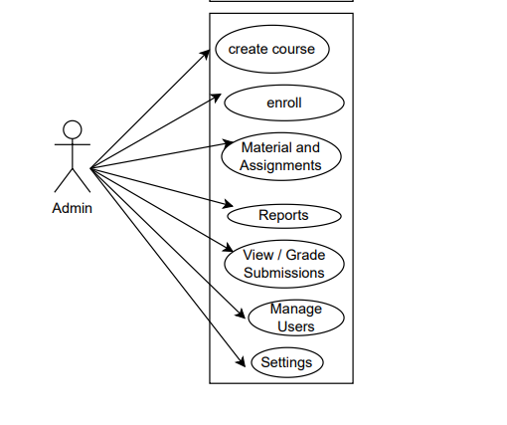

# Swimlane Diagram

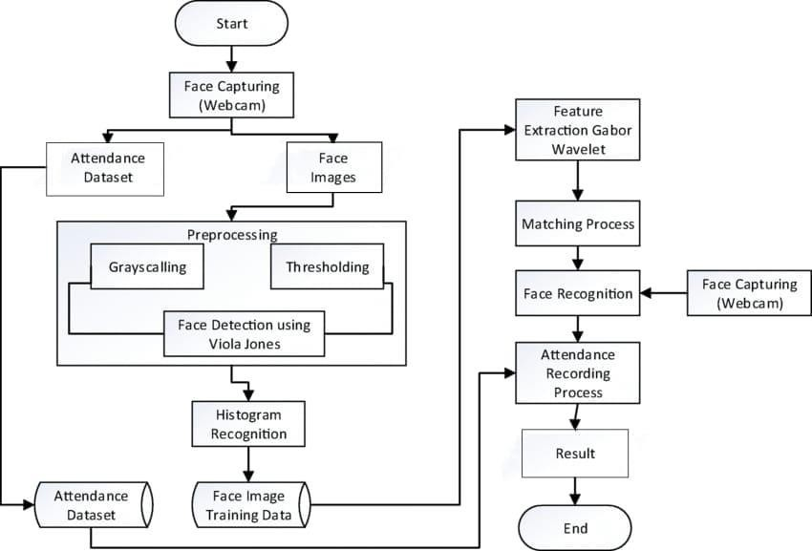

## DFD Diagrams

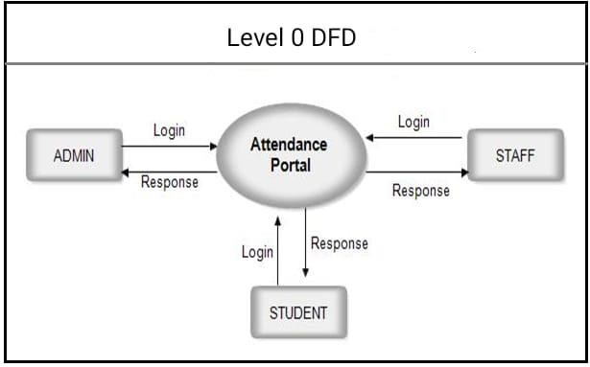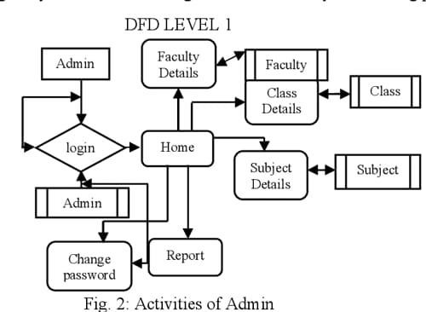

**Software Requirements Specification Document**

# Version 1.0

***Student Attendance Record Manager***

***Prepared by – Kashish Aggarwal- 102103490 Rachit Chaurasia – 102103592***

***Jival Kapoor – 102013644 Saakshi Gupta –102103509***

***MVPs***

# TABLE OF CONTENTS



**Chapter No. Topic Page No.**

|  |  |  |
| --- | --- | --- |
| 1. | Introduction | 14 |
| 1.1 | Purpose of this Document | 14 |
| 1.2 | Scope of the Development Project | 14 |
| 1.3 | Definitions, abbreviations and acronyms | 15 |
| 1.4 | References | 16 |
| 1.5 | Overview | 16 |
| 2. | Overall Description | 16 |
| 2.1 | Product Perspective | 16 |
| 2.2 | Product functions | 16 |
| 2.3 | User Characteristics | 16 |
| 2.4 | Operating Enviroment | 17 |
| 2.5 | Design and Implementation Constrains | 17 |
| 3. | System requirements specification | 17 |
| 3.1 | Technical requirement | 17 |
| 3.2 | Functional requirements | 17 |
| 3.2.1 | Non-functional requirements | 18 |
| 3.2.2 | Student requirements | 18 |
| 3.2.3 | Administrator requirements  Performance requirements | 18  19 |
| 3.3 |
|  |  | 19 |
| 3.4 | Other requirements | 19 |

1. Change History
2. Document Approvers

# Introduction

## Purpose

The document's goal is to compile and evaluate all of the various suggestions that have been made for defining the system and its consumer-related requirements. In order to better understand the project, we will also outline concepts that may be developed later and record ideas that are being considered but may be left as the product develops. Additionally, we will predict and organise how we hope this product will be used.

* 1. Scope of the Development Project

The main objective is to make a software capable of marking and recording attendance and other features to enrich the user experience of the students. It will be based on using Django and many other technologies to make it robust and this will function by using the camera of the device while incorporating AI to recognize the face of the user to mark the attendance and also using the location to confirm the location. Since this will be a Web based application so there is no need to download any software and it will be fast due to that reason.

The Software will be able to perform the following functions:

1. Card identification and verification: It must be able to authenticate the card user by matching the identification number. and access code against the values stored in the database.
2. Record user presence: Must be able to record user presence by typing user id. in the corresponding database table. Thus, write operations is performed to database server
3. Update access rights: The software must be able to update access rights to a specific user's card and database, where only system administrators will be able to modify the rights themselves.
4. Determine Access Permission Levels: The software must be able to determine whether a specific user has been denied access from a specific lab due to a policy violation. Only the security officer will be able to view the results of this operation.
   1. Definitions, abbreviation and acronyms

|  |  |
| --- | --- |
| Term | Definition |
| Python | Python is a high-level, general-purpose programming language. |
| GUI | The GUI, graphical user interface, is a form of user interface that allows users to interact with electronic devices through graphical icons and audio indicator such as primary notation, instead of text-based UIs, typed command labels or text navigation. |
| Id | '"ID" is a short form for "identity" or "identification" |
| HTML | The HyperText Markup Language or HTML is the standard markup language for documents designed to be displayed in a web browser. |
| Student | Student of the respective institute |
| Database | In computing, a database is an organized collection of data stored and accessed electronically. |
| SRSs | A SOFTWARE REQUIREMENTS SPECIFICATION is a description of a software system to be developed. It is modelled after business requirements specification. |
| User | It can either be student or instructor. |
| SID | It is student identity. |
| Instructor | Instructor from the respective institute |
| Open CV | OpenCV is a library of programming functions mainly aimed at real-time computer vision. |
| CSV | A comma-separated values file is a delimited text file that uses a comma to separate values. Each line of the file is a data record. |
| Numpy | NumPy is a library for the Python programming language, adding support for large, multi-dimensional arrays and matrices, along with a large collection of high-level mathematical functions to operate on these arrays. |
| Pandas | pandas is a software library written for the Python programming language for data manipulation and analysis. |

|  |  |
| --- | --- |
| Django | Django is a free and open-source, Python-based web framework that follows the model–template–views architectural pattern. |

* 1. References
  2. Overview

The remainder of this document provides a general description, including user characteristics of this project, product hardware, and product functional and data requirements. A general description of the project is discussed in Section 2 of this document. Section 2 lists the functional requirements, data requirements and constraints and assumptions made in designing the multi-purpose system. It also provides the user with a view of the product usage. Section 3 lists specific product requirements and discusses external interface requirements and provides a detailed description of functional requirements.

# Overall Description

### Product Perspective

The proposed Attendance Management System will take care of the employee attendance in any organization at any point of time. The system can keep a track of the employee’s presence, time-in and time-out. It can automatically generate reports and graphs of their availability which can be monitored by the higher authority of the respective organization.

### Product Functions

* + - The main objective of this project is to reduce the manual work.
    - The system is capable of managing employee’s presence, time-in and time- out. It can generate reports of their availability.

### User Classes and Characteristics

We have 2 types of users of the system.

1. Employee
2. Admin

Following functionalities can be performed by the admin:

* + Login
  + Register new employees to the system
  + Add employee photos to the training data set
  + Train the model
  + View attendance report of all employees. Attendance can be filtered by date or employee.

Following functionalities can be performed by the employee:

* + Login
  + Mark his/her time-in and time-out by scanning their face
  + View attendance report of self

### Operating Environment

The server-side components of the system can have running windows or Linux OS with the necessary library supports of the system.

The client-side components of the software system must operate within common web browser environments using Secure Sockets Layer (SSL) / Transport Layer Security (TLS) cryptographic protocols at a minimum encryption level of 128 bits. The minimum set of browsers that must be supported is

* + - Google Chrome 44+
    - Mozilla Firefox.

### Design and Implementation Constrains

As the system is using face recognition feature to identify each employee of the organization, it must be able to identify each of them individually. According to this, system must be capable to mark their presence for the day and it should convey the same message to the employee as well.

# System requirements specification

### Technical requirement

* + 1. Hardware requirements
* a stand-alone computer (i3 5th gen 8 GB ram or higher)
* high quality camera to capture images
* secondary memory to store all the image and database
  + 1. Software requirements
* Python 3.5 or more
* Windows 10 or higher
* latest version of all libraries

### Functional requirements

System functional requirement describes activities and services that must provide

* a user must be able to manage student records
* only authorised user must be able to use the system
* a system must be attached to wireless camera and face recognition should be smooth
* the administrator or the person who will be given the access to the system must login into the system before using it
* the information must be entered and managed properly

### Non-functional requirements

Non-functional requirements are characteristics or attributes of the system that can judge its operation the following points clarify them

* + - 1. Accuracy and precision: the system should perform its process with accuracy and precision to avoid problems
      2. Flexibility: the system should be easy to modify any wrong should be

correct

* + - 1. Security: the system should be secure and saving students privacy
      2. Usability: the system should be easy to deal with and simple to

understand

* + - 1. Maintainability: the maintenance group should be able to cope up with any problem when occurs suddenly
      2. Speed and responsiveness: execution of operations should be fast

Non-functional requirements are as follow:

* the GUI of the system will be user friendly
* the data that will be shown to the user will be made sure that it is correct and is available for the time being the system will be flexible to changes
* the system will be extended for changes and to the latest technologies
* efficiency and effectiveness of the system will be made sure
* the performance of the system will be made sure

### Student requirements

* A student needs to enter the proper details while registering him/her
* He/she needs to sit properly while capturing images of himself/herself
* At the time of taking attendance student need to sit properly facing the

camera

### Administrator requirements

* The administrator needs to log into the system at the time of registering the students in the face recognition process
* He/she must make sure that the student enters the detail properly

system

* only the administrator has the rights to manage any changes in the
* only the administrator is allowed to view the training set and the

testing set

* + only the administrator has the right to manage any changes in the stored data

### Performance Requirements

* A basic computing structure with a minimal amount of functioning ram and a fair processing power
* A system-integrated or a separate webcam with HD resolution for facial recognition
* A stable internet connection to connect to the server and upload information

### Other Requirements

•Webcam should be of decent resolution (Atleast HD)

* Nothing other at this time

# Design Phase

## Class Diagram

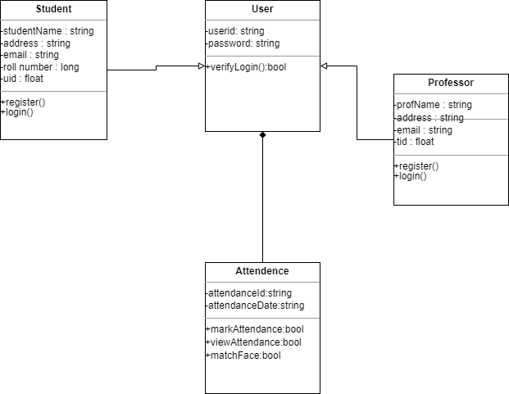

### ER Diagram

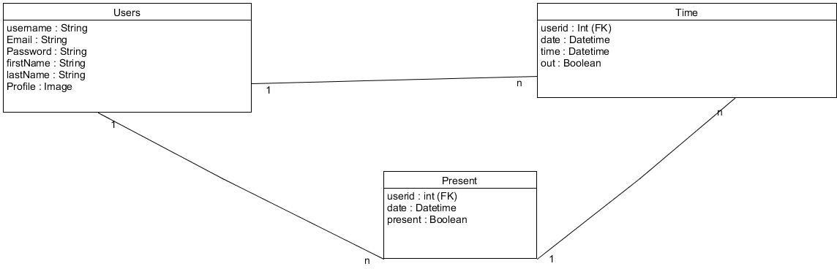

Sequence Diagram

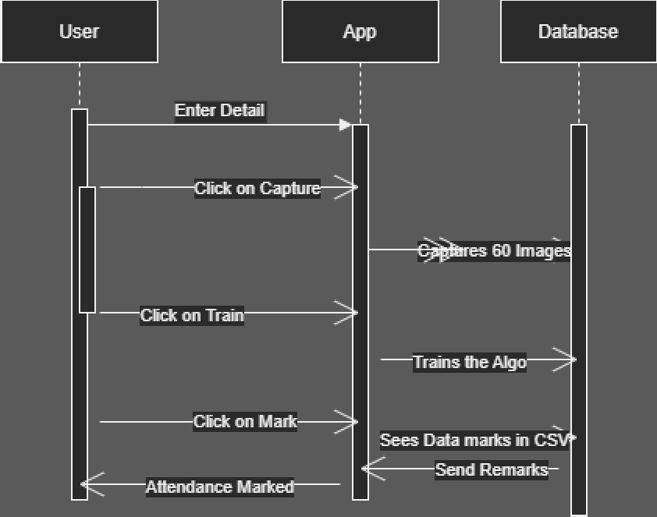

### Collaboration Diagram

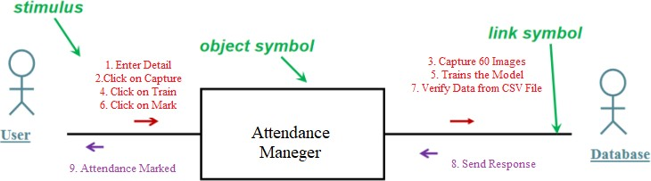

State Chart Diagram

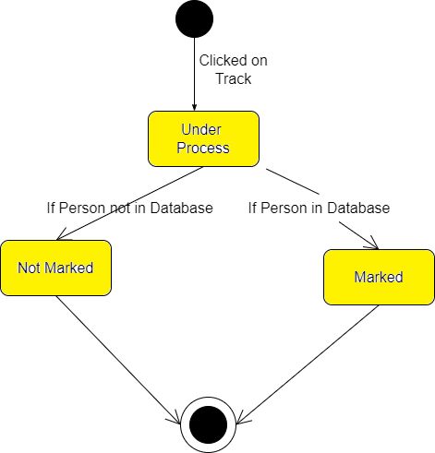

### Component Diagram

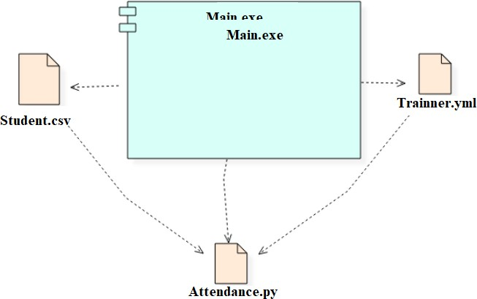

Deployment Diagram

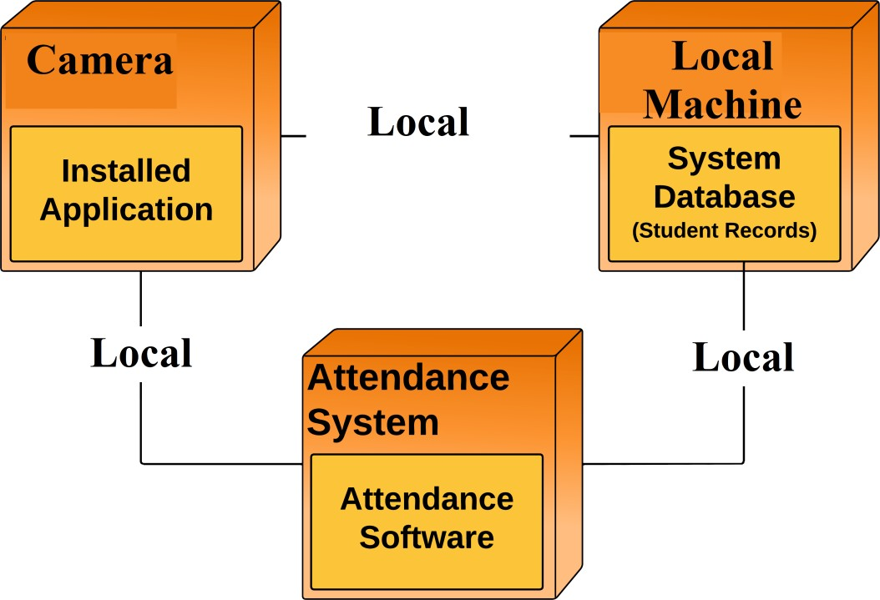

# Screenshots

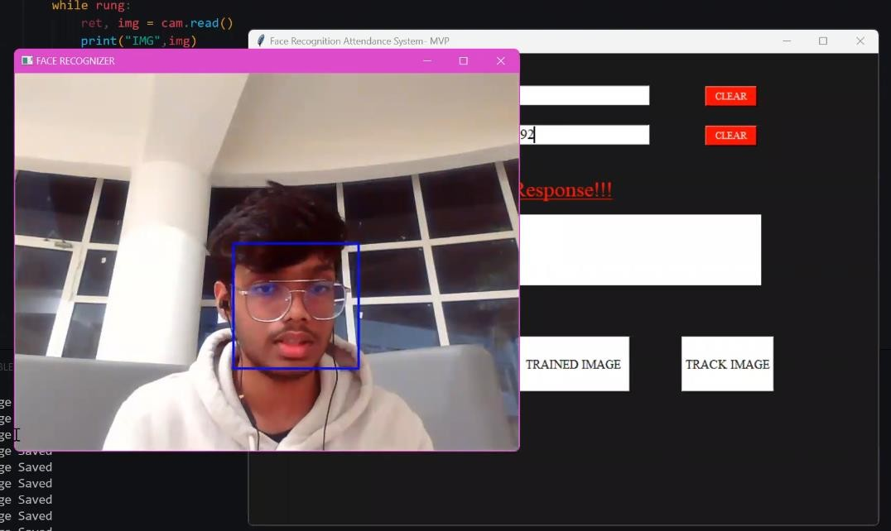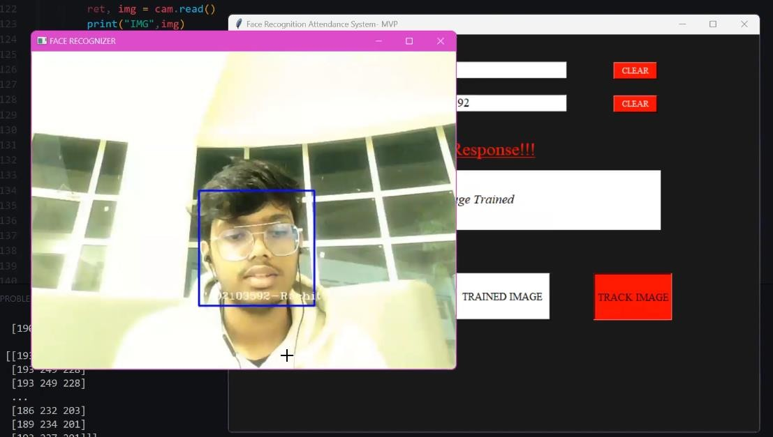

**Test Cases**

